Day in the Life of the Hudson River 10/13/22
Water’s Edge Garden, Randall’s Island Park, NY
Harlem RIVER MILE: 1
Salt Front: ~RM 76
Randall’s Island Park Alliance and Central Park East II– Jacqueline Wu
21 students & 4 adults
Latitude 40.789°N & Longitude – 73.933°W
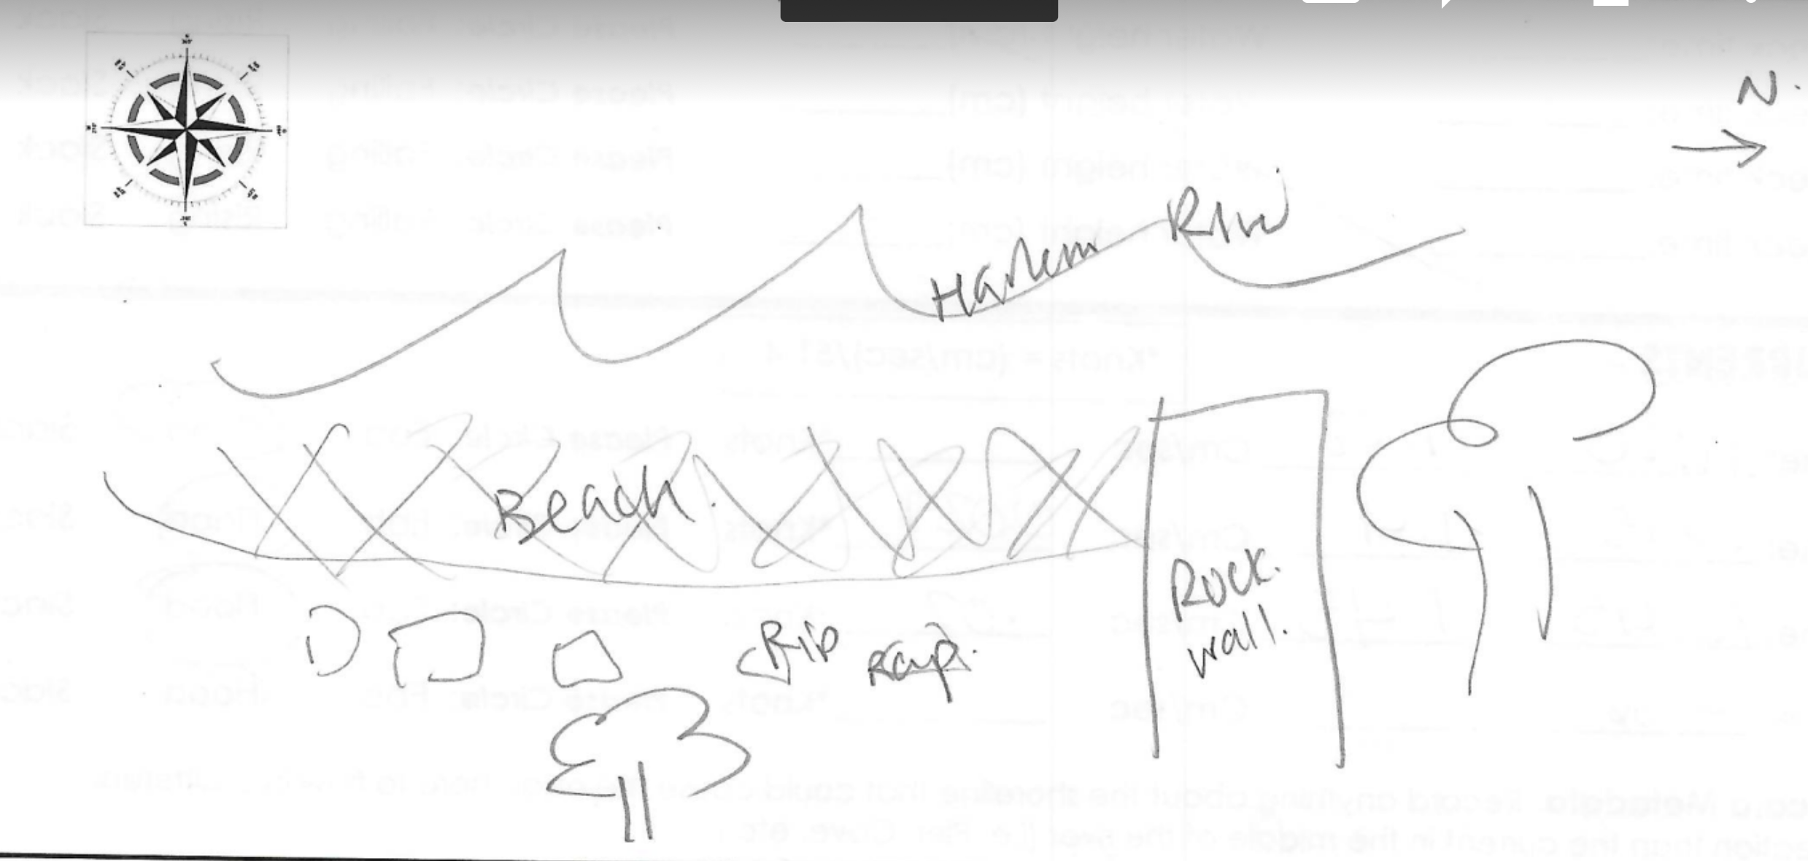
Location: Water’s Edge Garden, Randall’s Island Park, NY
Area: By the beach south of the concrete outcropping.
Sampling Site: Beach, altered banks, grassy, RipRap, concrete bulkhead, pipe entering the water
Surrounding Land Uses: 30% Urban/Residential; 50% Beach; 20% Other
Shoreline: 30% Rocky, 70% Sandy
River Bottom: Sandy
Water: Choppy
Plants in the Water: 100% Fucus visiculosus (AKA bladder wrack/rock weed/sea grapes), drift algae as well
*NR = Not read/recorded
ITEM |  | Time |  | Reading |  |  |  | Comments
Physical
Air Temperature- |  | 9:49 AM  9:50 AM  10:22 AM  11:32 AM |  | 21.01°C  16.1°C  21.18°C  21.3°C |  |  | 69.8°F  61°F  69.8°F  70.4°F
Wind Speed: |  | 9:49 AM  11:32 AM |  | Anemometer  1.7 mph  0.6 mph |  |  | Beaufort  NR | Direction  S/SW  S/SW
Weather today |  | 11:37 AM |  | >75% cloud cover |  |  | No Rain
Weather the past 3 days: |  | Sunny, no rain
Tides- NR |  | Time |  | Rising, Falling, Unchanged |  |  | Water Height (cm)
Current- |  | Time |  | Cm/sec |  | Knots | North/South | Ebb/Flood/Still
 |  | 9:36 AM  10:15 AM  10:45 AM  11:20 AM |  | 6.1  1.4  1.45  1.08 |  | -  0.027  0.02  - | NR  NR  NR  NR | Flood  Flood  Flood  Flood
Water Temperature- |  | 9:50 AM  11:20 AM |  | 17.3°C  17.5°C |  |  | 63°F  63.5°F | Averages of 2
Turbidity- Long Sight Tube (120 cm) |  | 9:40 AM  10:10 AM |  | 43.2/47/58 cm  22/29/59 cm |  |  | Average 49.4 cm  Average 36.6 cm
Chemical
Salinity-Hydrometer |  | 10:00 AM |  | 27/28/27 |  |  | 27.3 ppt
Standardized Salinity – Refractometer |  | 9:22 AM |  | 25,500 ppm
DO – Meter/Probe |  | Time  9:40 AM  11:28 AM  NR |  | Temp  NR  NR  NR |  |  | ppm DO  8 ppm  8 ppm  7 ppm | % saturation  NR  NR  NR
pH – Color Match Kit/test strips |  | 10:35 AM |  | 6
Nitrates- NR
Phosphates- NR
Alkalinity- NR
Biological-
Fish – Seine |  | Number |  | Name |  |  | Length of longest | Length of smallest
9:30 AM-10:40 AM |  | 3  121  29 |  | Striped Bass  Atlantic Silverside  Atlantic Menhaden |  |  | -  10 cm  32 cm | -  6 cm  5 cm
Fish Totals |  | TOTAL: 153 |  | Diversity: 3
Macroinvertebrates |  | Number |  | Name |  |  | Length of longest | Length of smallest
 |  | 1 |  | Blue Crab
Macroinvertebrate Totals |  | TOTAL: 1 |  | Diversity:1
Sediment Core – 10:45 AM collected
Length | H2S smell |  | Oxid Top |  | Oil |  | Grain Size | Other Features
10 cm | No |  | No |  | No |  | Abundant: sand  Common: gravel, pebbles | Rare: wood, shells, brick
Boats-
 | Time |  | Name |  | Color |  | North/Southbound | Light/Loaded
Commerical | NR |  | 3 NYPD Boats |  | NR |  | Southbound | NR
Recreational

